


EDMUS Foundation
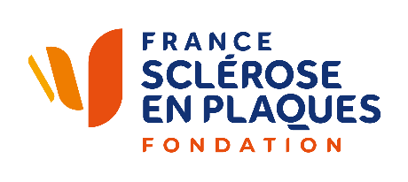
11th call for research proposals
In partnership with

administrative
file

Files to be downloaded from the website: www.fondation-edmus.org
Contact and information : Sofia Smaoui
call@fondation-edmus.org

DEADLINE for submission
March 31, 2026
results : SUMMER 2026

Project name:

Project title:

Project Coordinator/principal investigator
Title | Prof. Dr. Mr Mrs
Last name
First name
Address
E-mail
Phone number

Project summary (10 lines) for lay audience, en français

Requested budget
- Total: euros

Experts
Names, addresses, emails, of 3 international experts competent within your project’s field (excluding collaborators)
1.
2.
3.

Experts to be excluded due to potential conflicts of interest
1.
2.
3.

Structure receiving the funds
INSERM CNRS UNIVERSITY HOSPITAL other:……………………………………………..
Contact name
Address

Email

Phone

VALORISATION PATENT POLICY
All inventions or discoveries resulting from a research project supported by EDMUS Foundation, in whole or in part, with industrial or financial applications must be reported promptly to the Central Office of the EDMUS Foundation.

Ethical approval and regulations issues

If ethical approval or regulations issues are required for a clinical trial or a research project, the scientist in charge must obtain the appropriate authorisation according to the organism involved and the local laws of the country concerned.

City : ______________________________________, date : ___________________________________________

Last and first names of project coordinator:

Project coordinator’s signature:

